1) Describe the role of the Application Layer in the OSI model. Explain HTTP and FTP protocols in detail.
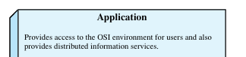
Role of the Application Layer in the OSI Model
- Topmost Layer of OSI
  - The Application Layer is the seventh and highest layer in the OSI model.
  - It is closest to the end-user, meaning that both the user and the application layer interact directly with software applications.
  - Unlike lower layers, which mainly provide data transfer and networking functions, the application layer provides network services to end-user applications.
- Primary Role
  - It enables users and application processes to access network services.
  - It provides interfaces and support for services such as email, file transfer, database access, and network management.
  - Essentially, it defines how applications interact with the network.
- Functions of the Application Layer
According to Stallings, the main functions include:
  - Identification of communication partners – Ensures that the intended application or user is properly identified on the network.
  - Determination of resource availability – Verifies whether the required communication resources (such as bandwidth or server availability) are present before initiating communication.
  - Synchronization of communication – Establishes agreement between applications on how communication should proceed.
  - Providing user services – Offers standardized services such as:
    - File Transfer, Access, and Management (FTAM)
    - Electronic Mail (SMTP, X.400)
    - Virtual Terminal (Telnet)
    - Directory Services (X.500)
    - Network Management protocols (SNMP)
- Difference from Lower Layers
  - Lower layers (physical, data link, network, transport, session, presentation) are mostly about data transport and reliability.
  - The Application Layer is not about transport, but about providing a communication interface for applications.
  - It is service-oriented, focusing on the needs of users and processes, not just the movement of bits.
- Examples of Application Layer Protocols (as per the textbook)
  - FTP (File Transfer Protocol) – for file transfer.
  - SMTP (Simple Mail Transfer Protocol) – for electronic mail.
  - HTTP (Hypertext Transfer Protocol) – for web services.
  - SNMP (Simple Network Management Protocol) – for managing devices in a network.
  - Telnet – for virtual terminals.
HTTP and FTP protocols
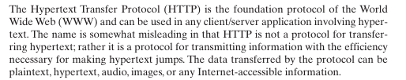
HTTP (Hypertext Transfer Protocol)
Introduction
- HTTP is a protocol used for transferring hypertext documents (mainly web pages) on the World Wide Web (WWW).
- It defines how messages are formatted and transmitted between a client (web browser) and a server (web server).
- It operates at the Application Layer of the OSI model.

Working of HTTP
- Client Request
  - The user enters a URL (e.g., http://www.example.com) into a browser.
  - The browser (client) sends an HTTP request to the web server.
  - The request contains method, headers, and sometimes body data.
- Server Response
  - The server receives the request and processes it.
  - It sends back an HTTP response containing a status code (like 200 OK, 404 Not Found) and requested data (HTML, images, etc.).
- Connection Characteristics
  - HTTP is based on TCP (Transmission Control Protocol) for reliable data transfer.
  - By default, it uses Port 80 (or Port 443 for HTTPS).
  - HTTP is stateless: each request/response is independent; the server does not remember previous interactions.
Advantages of HTTP
- Simple and easy to implement.
- Supports multimedia (text, images, audio, video).
- Based on client-server model, widely used.
Disadvantages
- No security (data is sent in plain text). → Solved by HTTPS (HTTP Secure).
- Stateless, so extra mechanisms like cookies/sessions are needed.
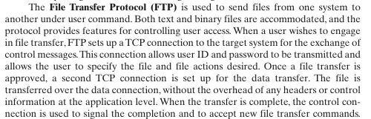

Introduction
- FTP is a standard protocol for transferring files between two computers over a network.
- It is used to upload files to a server or download files from a server.
- It also works at the Application Layer of the OSI model.

Working of FTP
- Control and Data Connections
  - FTP uses two separate TCP connections:
    - Control Connection (Port 21): For commands and responses.
    - Data Connection (Port 20): For actual file transfer.
- Client-Server Interaction
  - The client connects to the server via the control connection.
  - The user logs in (with username and password or anonymously).
  - Commands like LIST, GET, PUT are sent over the control connection.
  - Files are transferred over the data connection.
Advantages of FTP
- Allows large file transfers.
- Provides authentication (username & password).
- Can resume interrupted downloads (depending on implementation).
Disadvantages
- Data is not encrypted → passwords and files can be captured.
- Replaced in many cases by SFTP (Secure FTP) and FTPS for secure transfers.

===========================================================================
===========================================================================

2) What is DNS? Explain its purpose and working with an example.

===========================================================================
===========================================================================

3) Explain the major design issues of the Data Link Layer. Why are error detection and flow control important?
Data Link Layer
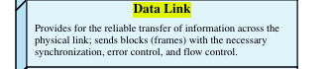
The Data Link Layer (DLL) is the second layer of the OSI model. Its main job is to provide reliable communication between two directly connected nodes over a physical link. To achieve this, several important design issues must be addressed:
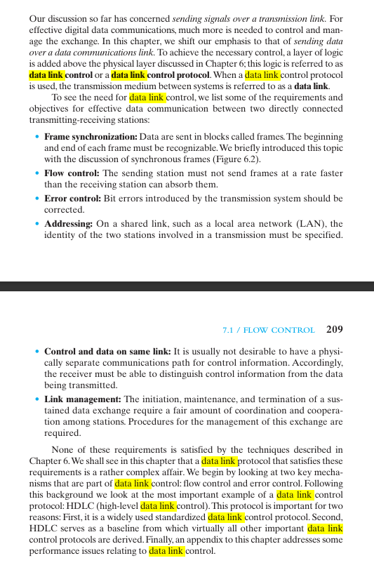
1. Framing
- Definition: Framing is the process of breaking the raw bitstream from the physical layer into manageable units called frames.
- Need: Without framing, the receiver cannot distinguish where one message ends and the next begins.
- Techniques:
  - Character count
  - Byte stuffing
  - Bit stuffing
  - Flag-based delimiters

2. Error Control
- Definition: Ensures that frames are transmitted without errors (or at least that errors are detected and corrected).
- How it works:
  - Uses techniques like checksums, parity bits, CRC (Cyclic Redundancy Check).
  - If an error is detected, retransmission is requested.
- Purpose: Prevents corrupted data from propagating to higher layers.

3. Flow Control
- Definition: A mechanism that ensures that the sender does not overwhelm the receiver with too much data at once.
- How it works:
  - Stop-and-Wait Protocol
  - Sliding Window Protocols (Go-Back-N, Selective Repeat)
- Purpose: Matches the sender’s speed with the receiver’s processing capability.

4. Addressing
- Definition: DLL must identify which device on the shared link should receive the frame.
- How: Uses MAC addresses (physical addresses) for unique identification of nodes.

5. Access Control (Medium Access Control – MAC)
- Definition: When multiple devices share the same link (e.g., Ethernet, Wi-Fi), the Data Link Layer controls who gets to use the channel and when.
- Techniques:
  - CSMA/CD (Carrier Sense Multiple Access with Collision Detection)
  - CSMA/CA (Collision Avoidance)
  - Polling, Token Passing

6. Reliable Delivery
- The DLL ensures that data frames are delivered without loss, duplication, or misordering, using acknowledgments (ACKs) and retransmissions (ARQ protocols).
Why are Error Detection and Flow Control Important?
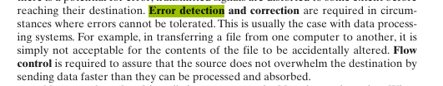
Error Detection – Importance
- Physical channels are noisy → errors (bit flips, losses) are common.
- If errors are not detected, corrupted data will reach higher layers, causing system crashes or wrong results.
- Example: CRC ensures that even small errors in transmission can be caught.
Key Point: Error detection maintains data integrity.

Flow Control – Importance
- Sender may transmit faster than the receiver can process.
- Without flow control, receiver buffers may overflow, leading to data loss.
- Example: Sliding window ensures that only as many frames as the receiver can handle are sent.
Key Point: Flow control ensures efficient and reliable communication by balancing sender and receiver speeds.

===========================================================================
===========================================================================

4) Describe the Stop-and-Wait Flow Control Protocol with the help of a diagram.
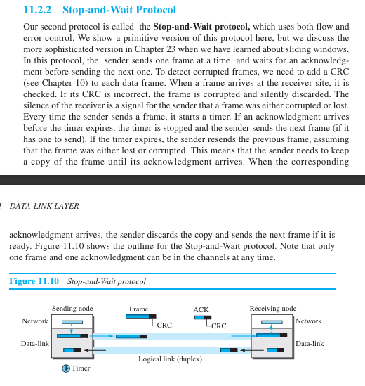

Introduction
- Stop-and-Wait is the simplest flow control protocol used in the Data Link Layer.
- It ensures that the sender does not overwhelm the receiver with data.
- In this method, the sender transmits one frame at a time and waits for an acknowledgment (ACK) before sending the next frame.

Working of Stop-and-Wait Protocol
- Sender side:
  - Sends one data frame.
  - Waits until an acknowledgment (ACK) is received from the receiver.
  - Only after receiving the ACK, it sends the next frame.
- Receiver side:
  - Receives the frame.
  - Processes it and sends an acknowledgment (ACK) back to the sender.
  - If the frame is damaged or lost, no ACK is sent → sender retransmits after timeout.
- Timeout mechanism:
  - If sender does not receive an ACK within a certain time, it retransmits the frame.

Diagram (Description for Drawing in Exam)
Sender Receiver
------------------------------------------------
[Frame 0] ------------------------> [Receives Frame 0]
<------------------------ [ACK 0]

[Frame 1] ------------------------> [Receives Frame 1]
<------------------------ [ACK 1]

[Frame 2] ------------------------> [Receives Frame 2]
<------------------------ [ACK 2]
Explanation of Diagram:
- Frames are sent one by one (Frame 0, Frame 1, Frame 2, ...).
- After each frame, the sender stops and waits for the acknowledgment.
- Receiver sends ACK (ACK 0, ACK 1, ACK 2) after successfully receiving each frame.
- If ACK is not received in time, the sender retransmits the frame.

Advantages
- Very simple and easy to implement.
- Ensures reliable delivery of data.
Disadvantages
- Inefficient for long-distance or high-speed links because the sender remains idle while waiting for the ACK.
- Low utilization of channel bandwidth.

===========================================================================
===========================================================================

5) Write short notes on any two of the following:
- Error detection and correction methods


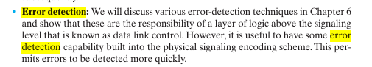

Error Detection and Correction Methods
Introduction
- During transmission, data may get corrupted due to noise, attenuation, interference, or distortion.
- To ensure reliable communication, error detection and correction methods are used at the Data Link Layer.

1. Error Detection Methods
Error detection ensures that the receiver can identify if an error occurred.
(i) Parity Check
- A parity bit is added to data to make the number of 1s either even (even parity) or odd (odd parity).
- Simple, but can only detect single-bit errors, not multiple.
(ii) Checksum
- The sender adds up all data segments (using 1’s complement arithmetic) and sends the sum (checksum).
- Receiver repeats the calculation and compares with checksum.
- Errors are detected if mismatch occurs.
(iii) Cyclic Redundancy Check (CRC)
- Uses polynomial division.
- Sender divides data by a generator polynomial and sends the remainder (CRC bits) with the frame.
- Receiver performs the same division → if remainder ≠ 0 → error detected.
- Very powerful: detects burst errors and multiple-bit errors.

2. Error Correction Methods
Error correction ensures that the receiver can locate and fix errors without retransmission.
(i) Automatic Repeat reQuest (ARQ)
- Error detection + retransmission.
- If error detected, receiver requests retransmission.
- Types:
  - Stop-and-Wait ARQ
  - Go-Back-N ARQ
  - Selective Repeat ARQ
(ii) Forward Error Correction (FEC)
- Extra redundant bits are added to allow the receiver to correct errors directly.
- Example: Hamming Code (detects and corrects single-bit errors, detects two-bit errors).
- Used in satellite and wireless communication where retransmission is costly.

- Sliding Window Protocols
Introduction
- Sliding Window Protocols are flow control methods used in the Data Link Layer.
- They allow the sender to transmit multiple frames before waiting for acknowledgment (ACK).
- This improves efficiency compared to Stop-and-Wait, especially in long-delay or high-speed networks.

Concept
- A window = range of sequence numbers of frames that can be sent or received before requiring an acknowledgment.
- Both sender and receiver maintain a window.
  - Sender window: Defines how many frames it can send without receiving ACKs.
  - Receiver window: Defines how many frames it can accept.
- As ACKs are received, the window “slides” forward, allowing transmission of new frames.

Types of Sliding Window Protocols
- Go-Back-N ARQ
  - Sender can send N frames before ACK.
  - If an error occurs, all frames from the error frame onward must be retransmitted.
  - Receiver only accepts frames in order.
- Selective Repeat ARQ
  - Sender retransmits only the erroneous frame, not the entire sequence.
  - Receiver can accept frames out of order and buffer them until the missing frame arrives.
  - More efficient but more complex.

Advantages
- Better utilization of bandwidth than Stop-and-Wait.
- Higher throughput on long-delay, high-capacity links.
Disadvantages
- More complex to implement (especially Selective Repeat).
- Requires buffer management at receiver side.

- HDLC protocol.
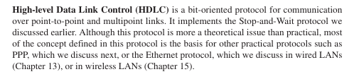

Introduction
- HDLC (High-Level Data Link Control) is a bit-oriented protocol for communication over point-to-point and multipoint links.
- Developed by ISO, widely used in WANs and data link communication.
- Provides framing, flow control, error detection, and error recovery.

Main Features
- Bit-Oriented Protocol
  - Uses bit stuffing and special flag 01111110 to mark the beginning and end of frames.
- Frame Structure
  - Flag (01111110): Marks frame boundary.
  - Address field: Identifies secondary station (receiver).
  - Control field: Indicates frame type (data, supervisory, unnumbered).
  - Information field: Carries user data (optional in control frames).
  - FCS (Frame Check Sequence): CRC bits for error detection.
  - Flag (01111110): Marks frame end.
- Types of Frames
  - I-frames (Information): Carry user data and control info.
  - S-frames (Supervisory): Used for error/flow control (ACK, NAK, etc.).
  - U-frames (Unnumbered): Used for control, link setup, and management.

===========================================================================
===========================================================================

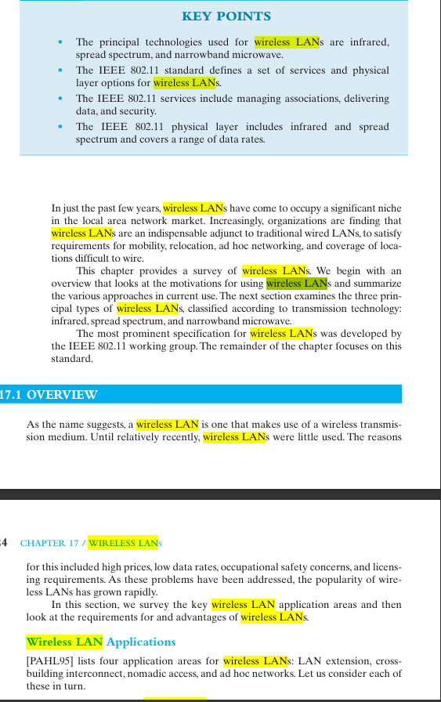
6) Write notes on Wireless LAN.

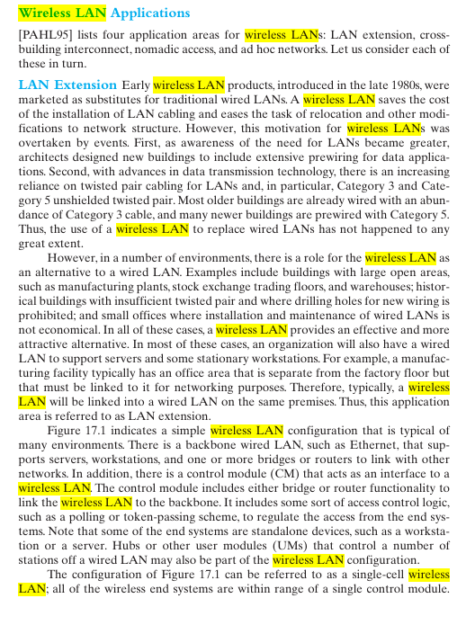
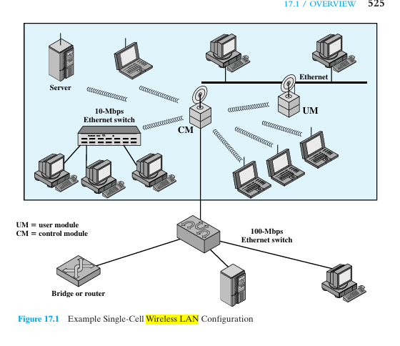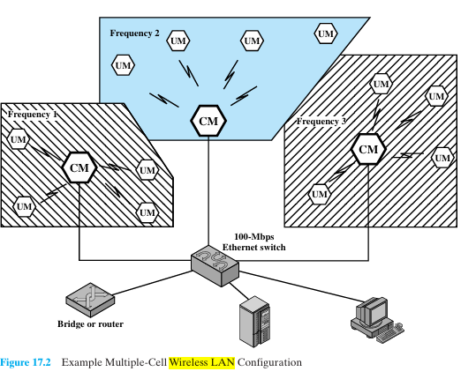

Introduction
- A Wireless Local Area Network (WLAN) is a LAN that uses radio waves or infrared signals instead of wired connections.
- Provides mobility and flexibility in accessing the network without physical cables.
- Most common standard: IEEE 802.11 (Wi-Fi).

Features of WLAN
- Medium of Transmission → Radio frequency (RF) or Infrared.
- Coverage → Typically within a building or campus (10m – 100m).
- Topology → Supports star, peer-to-peer (ad hoc), or extended service sets.
- Mobility → Users can move within coverage area and still maintain network connection.

Components
- Access Point (AP): Acts as a central transmitter/receiver and connects wireless devices to the wired LAN.
- Stations (Clients): Laptops, mobiles, IoT devices with wireless adapters.
- Distribution System: Interconnects multiple APs to form a larger WLAN.

Architecture
- Infrastructure Mode: Devices communicate via an AP (typical Wi-Fi setup).
- Ad Hoc Mode: Devices communicate directly without AP (peer-to-peer).

Advantages
- Easy installation and flexibility (no cables).
- Supports mobility and roaming.
- Scalable – more devices can join easily.
Disadvantages
- Lower speed compared to wired LAN.
- Security issues (eavesdropping, unauthorized access).
- Limited range and prone to interference.

Applications
- Offices, universities, homes (Wi-Fi networks).
- Public hotspots (cafés, airports).
- Industrial automation and IoT devices.

